# Appendix

## Appendix A: resource evaluation form

**Table 1: Resource Evaluation form**

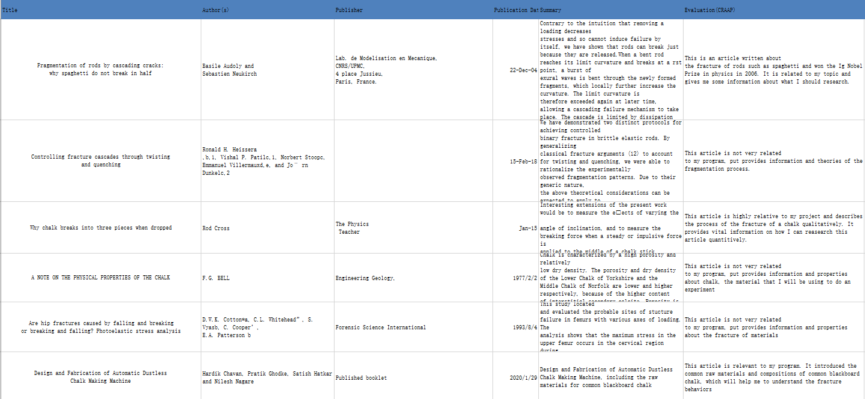

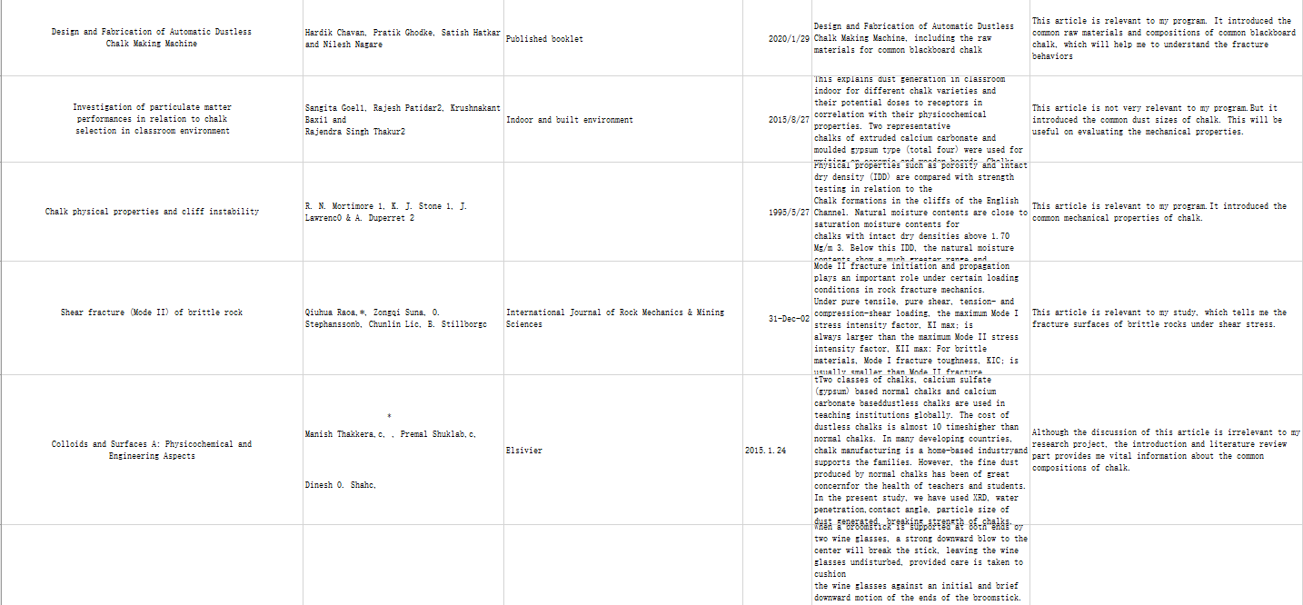

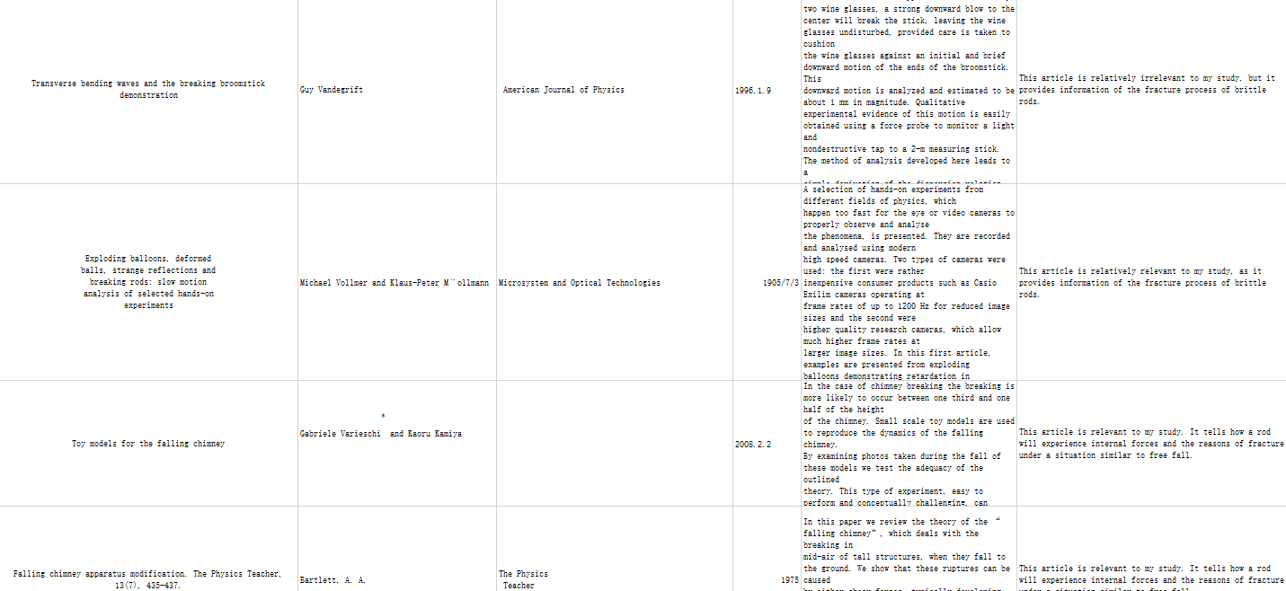

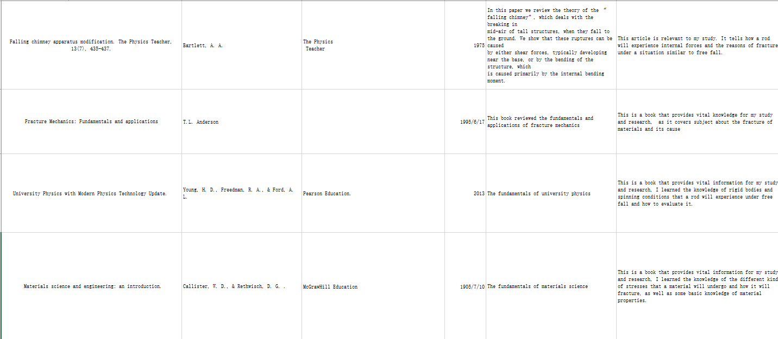

## Appendix B: Pictures and videos

**Fig 1: Fracture behavior experiment setup**

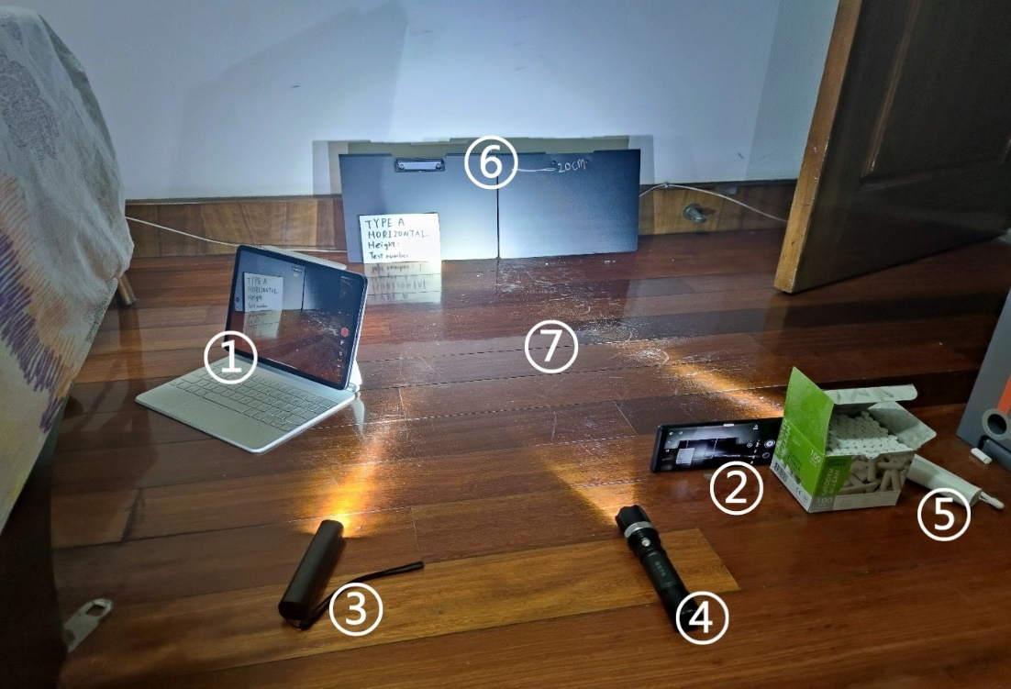

**Fig 2: Three types of chalk**

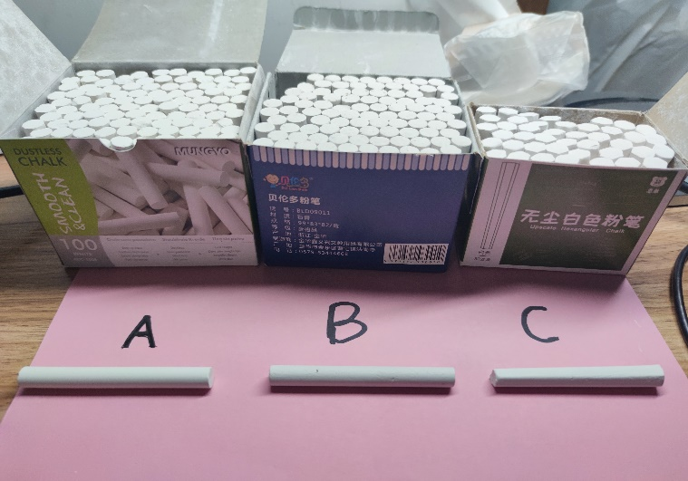

**Fig 3: Powder of chalk under 25x10 microscope**

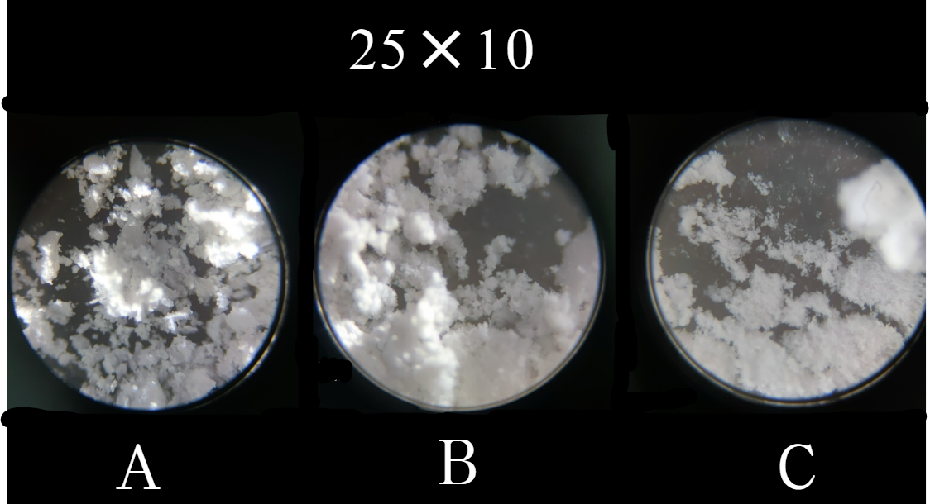

**Fig 4: Powder of chalk under 25x40 microscope**

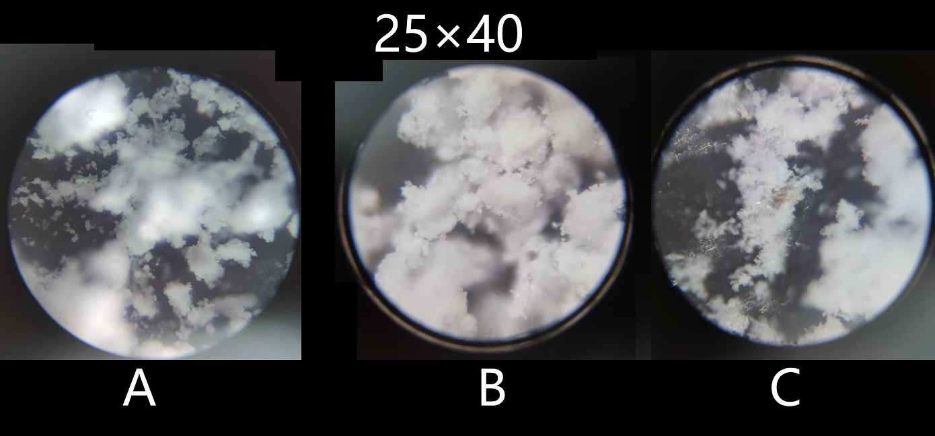

**Fig 5: Part of the videos that I filmed**

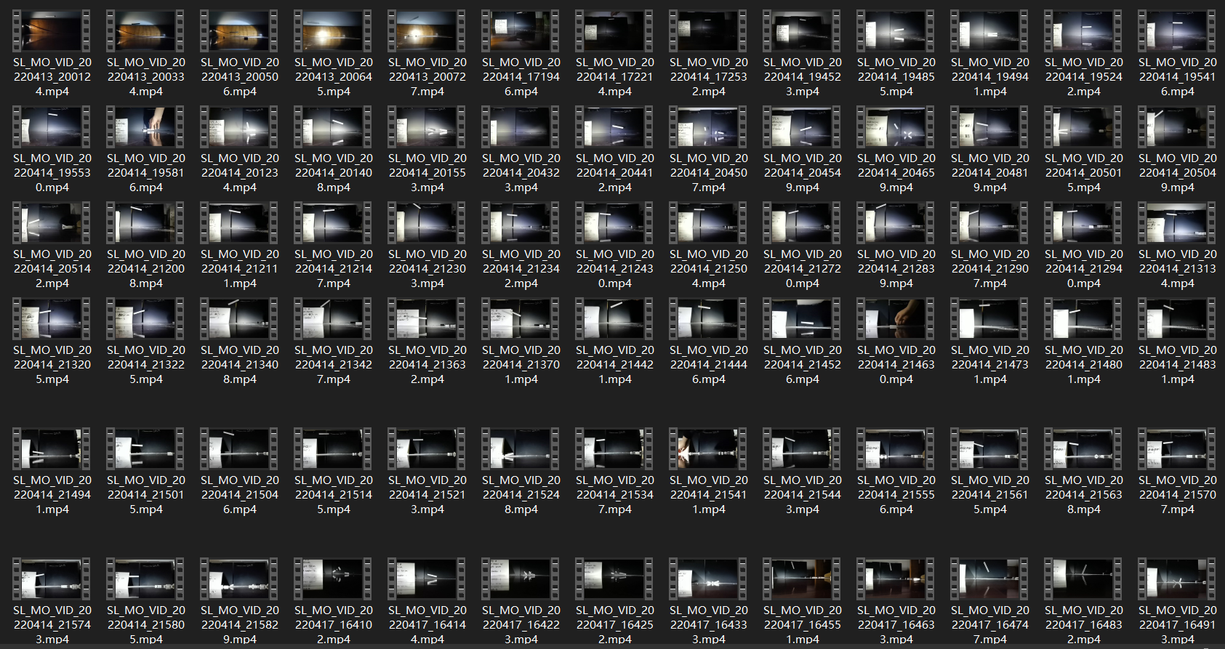

**Fig 6: Part of the pictures that I took**

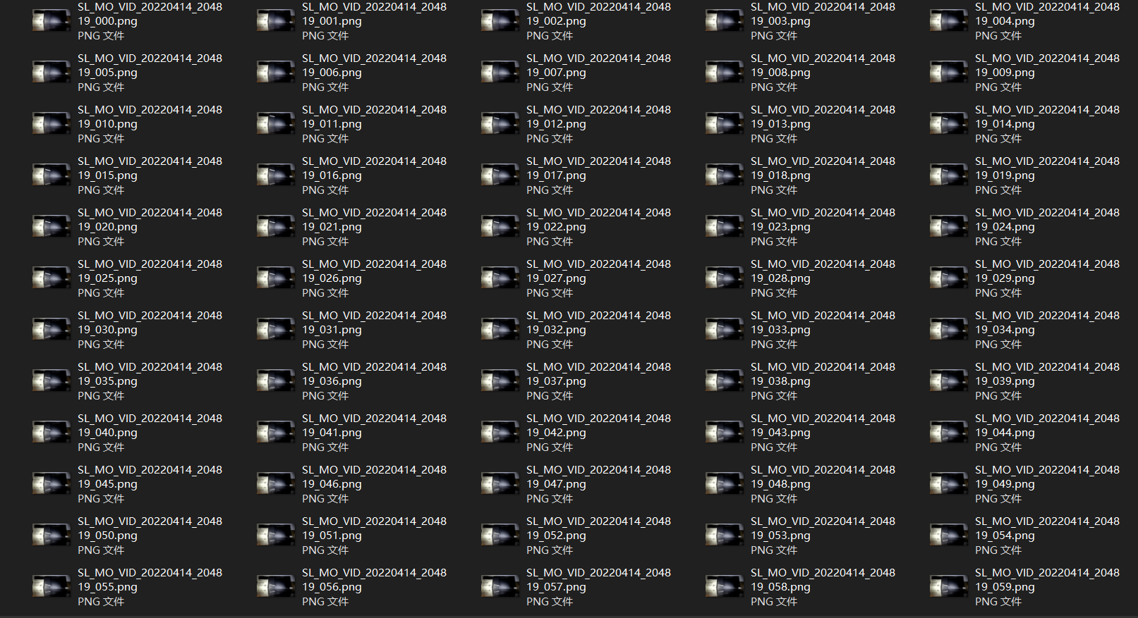

**Fig 7: Fracture surface of chalk with small ground angle**

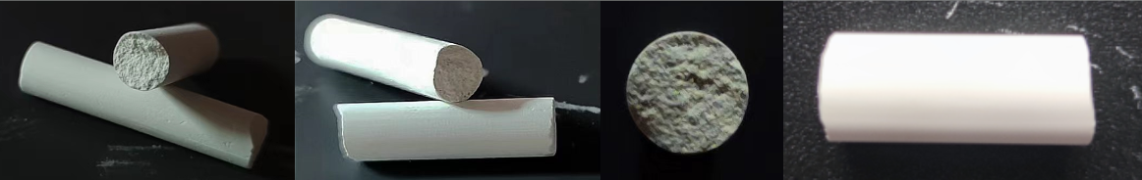

**Fig 8: Fracture surface of chalk with large ground angle**

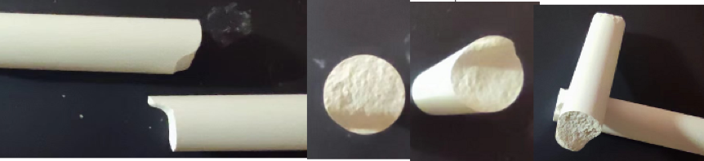

## Appendix C: Initial Mindmap and Gantt Chart

**Fig 9: Initial mindmap of the project**

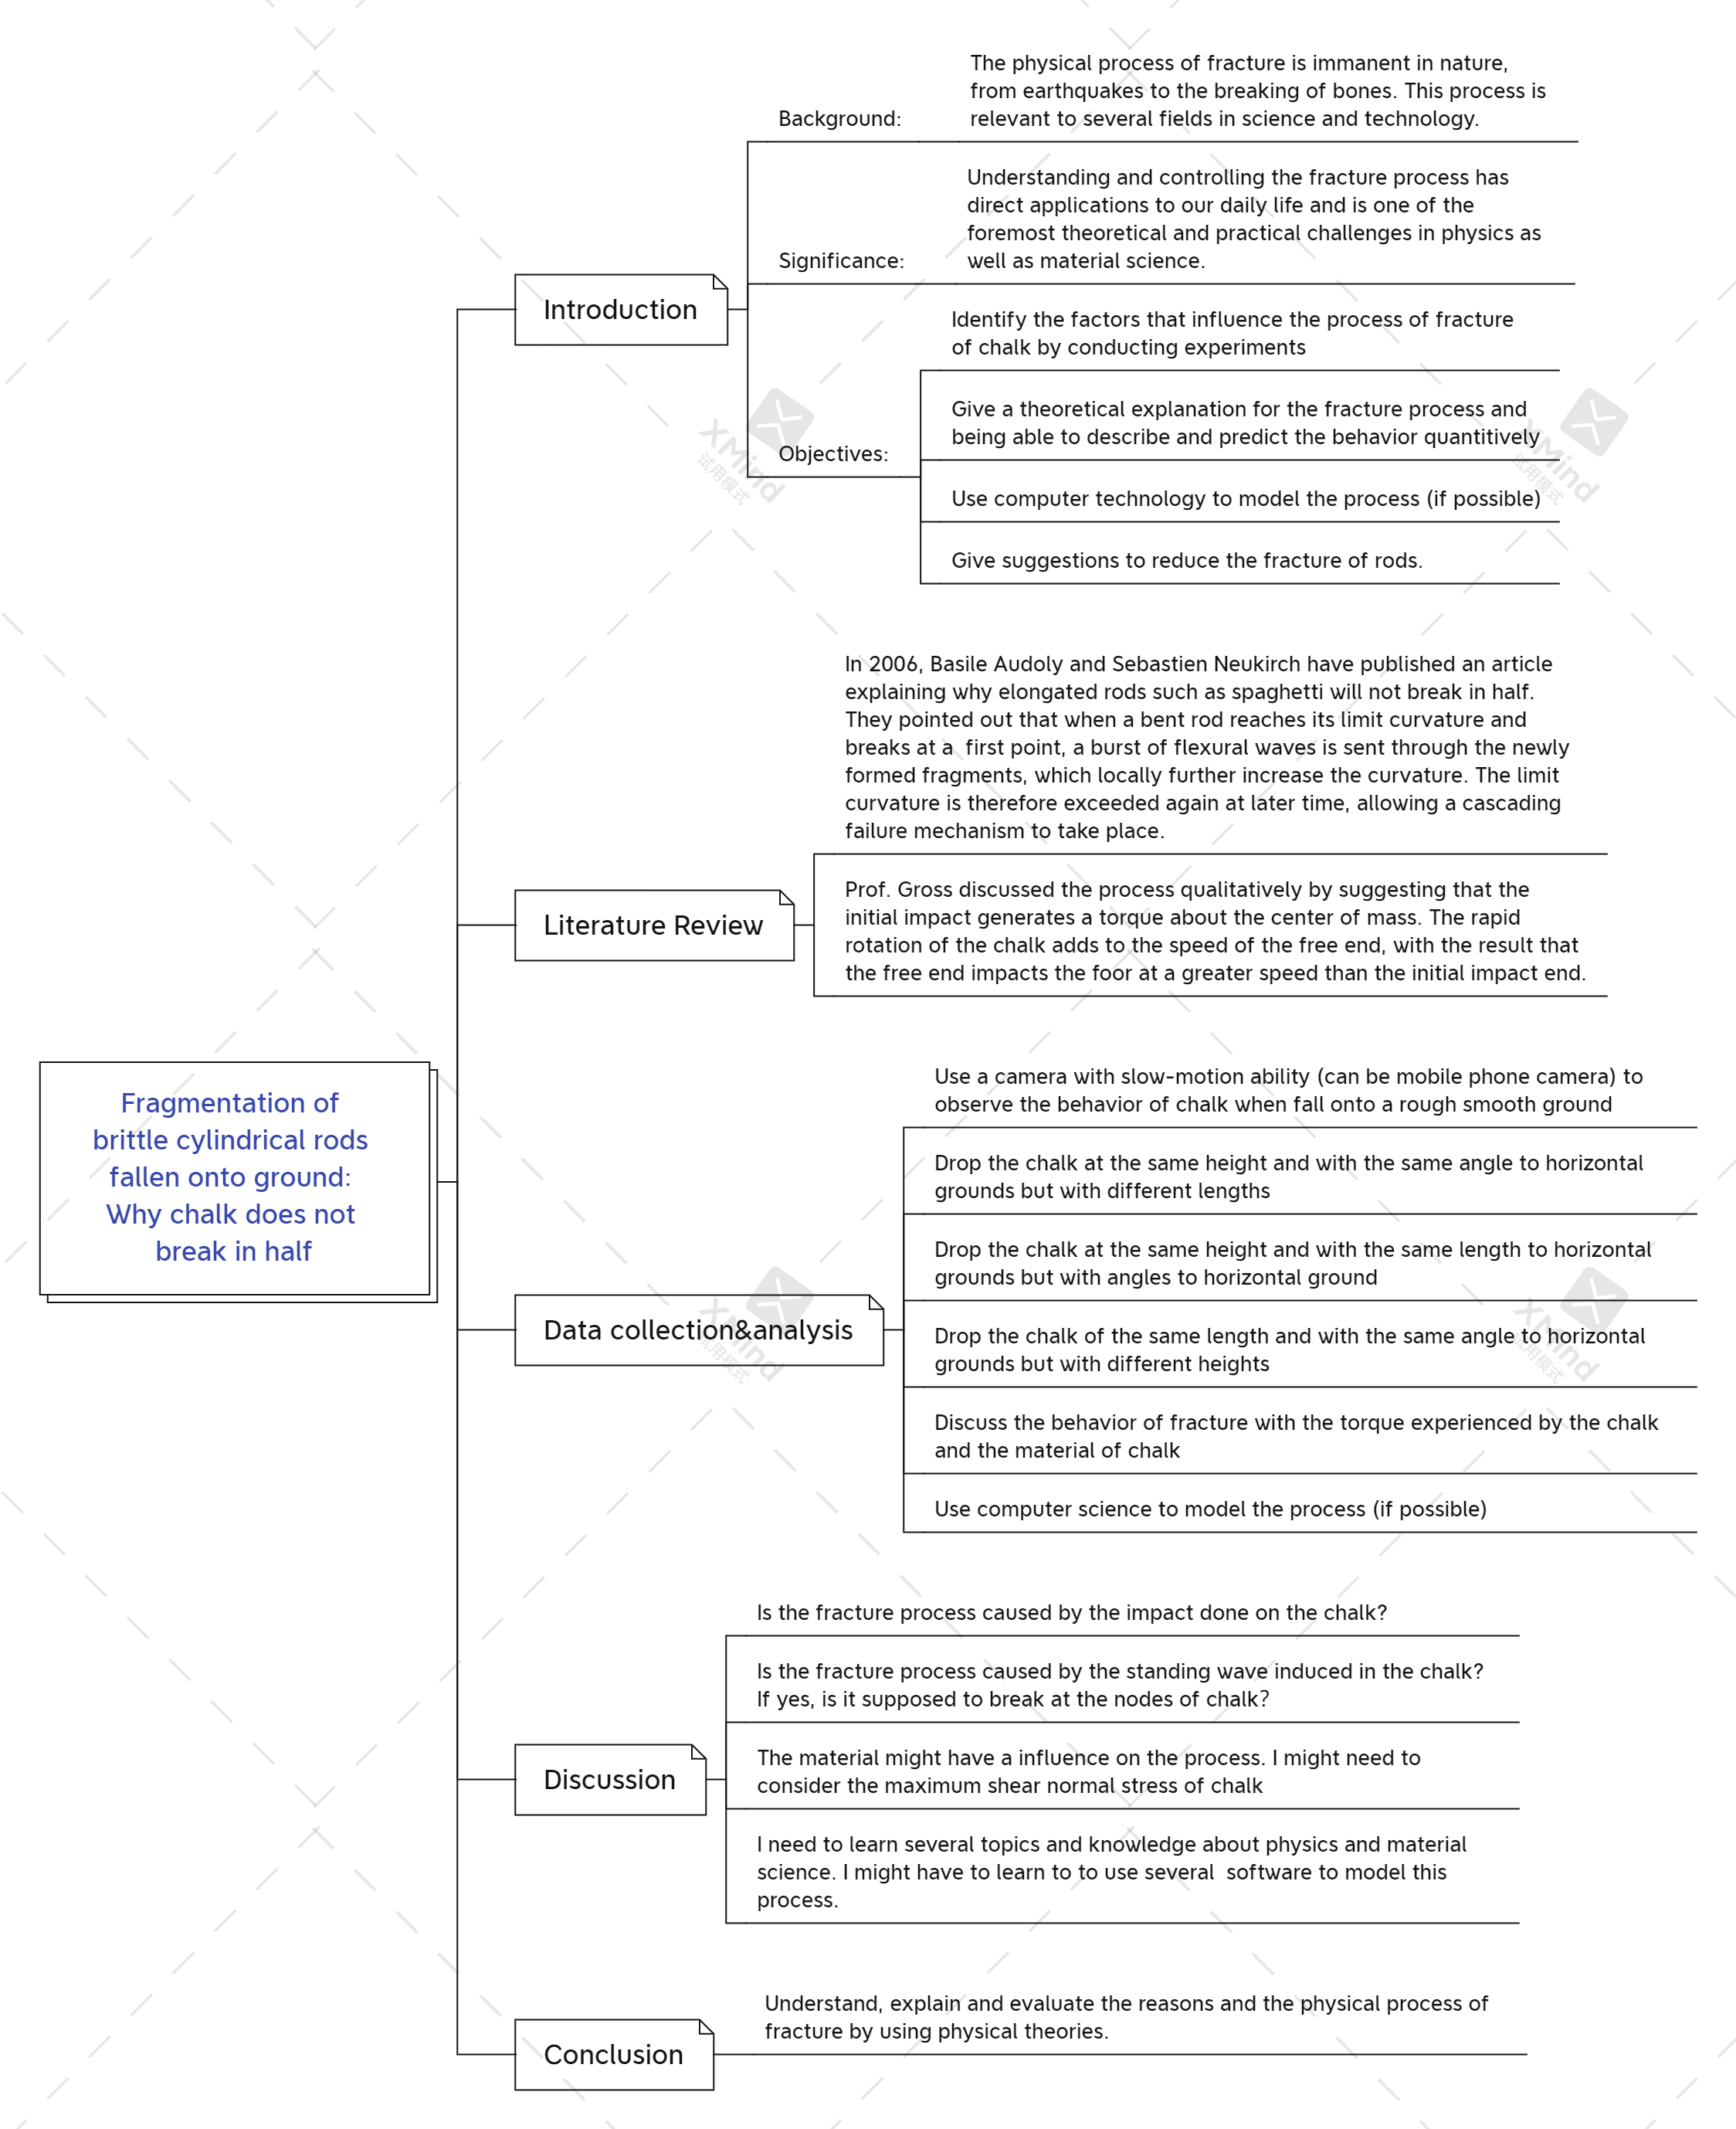

**Table 2: Gantt chart for the project**

